**CMPS 350 L02**

**Mohammed Al-Adbi, 202009684,** [**ma2009684@student.qu.edu.qa**](mailto:ma2009684@student.qu.edu.qa)

**Yahya Abdulselam, 202205057,** [**ya2205057@student.qu.edu.qa**](mailto:ya2205057@student.qu.edu.qa)

**Youssef Mohamed, 202003576,** [**ym2003576@student.qu.edu.qa**](mailto:ym2003576@student.qu.edu.qa)

[**https://github.com/Yahya-Abdulselam/Vendora-online-store**](https://github.com/Yahya-Abdulselam/Vendora-online-store)

**30/03/2024**

**Dr. Mucahid Kutlu**

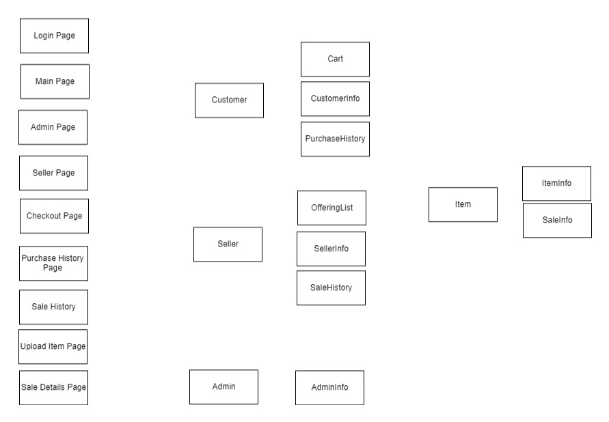**Application Design Documentation**

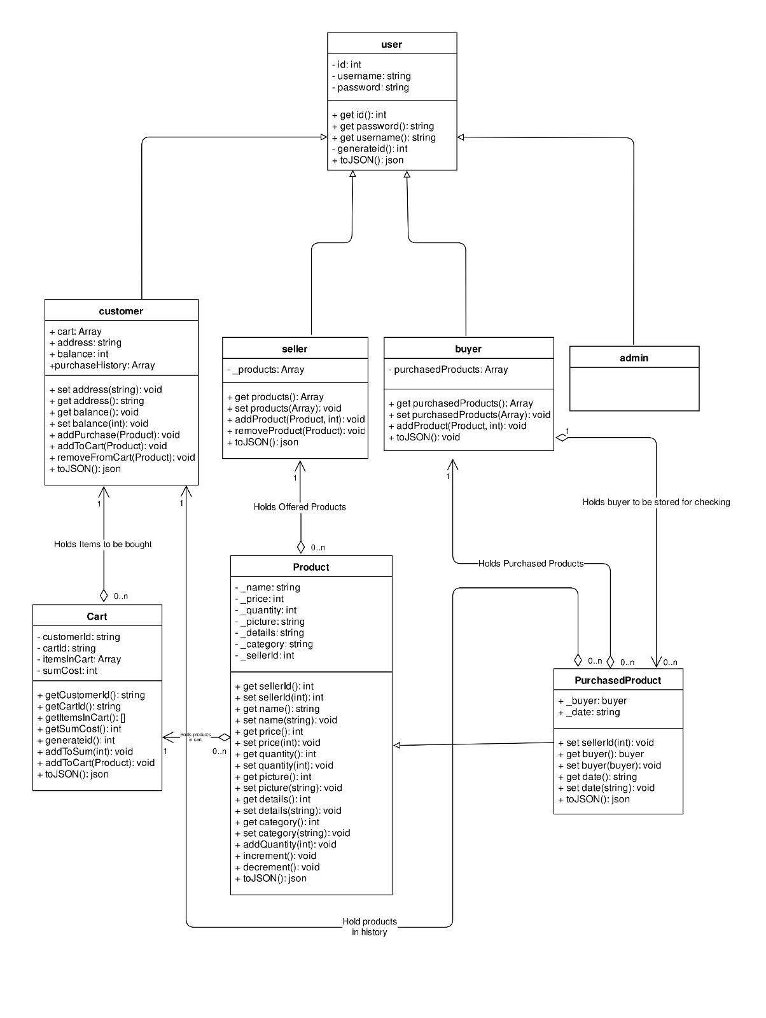

**Testing Screenshots**

* **A person holding shopping bags and a credit card

  Description automatically generatedMain page:** This is the first page that users see on the website
* **User login page:** This is the page that users see when they want to log in

* **A login screen with blue background

  Description automatically generatedSeller login page:** This is the page that sellers see when they want to log in
* **Seller page uploading product:** This is the page that sellers see when they want to upload a product

* **A screenshot of a computer

  Description automatically generatedSeller page after uploading product:** This is the page that sellers see after they upload a product
* **Searching for product:** This is the page that users see where they can search for a product to buy

* **Checkout page:** This is the page that users see after they click on Buy now to buy a product

* **Purchase history:** This is the page that users see after they buy a product when they want to check their purchase history

* **A computer screen shot of a black rectangular object with white text

  Description automatically generatedSeller page after a product has been sold:** This is the page that sellers see after a product has been sold